UET
Mardan
Major:Computer Science
Course:Programming Fundamentals
Submitted By:Talha Burhan(25MDBCS831)
&
M.Zakria(25MDBCS844)
Submitted To:Professor Usman Khan
Due Date:04/01/2025

Banking Management

System

Abstract
This project, the Banking Management System is an application developed using the C programming language. The system allows for two distinct user roles”Banker and User”enabling secure account management, funds transfer, and transaction history tracking. By Using binary files we ensure that the system records remain saved even after the program is closed.

Introduction
Efficient data management is crucial for financial institutions. While large-scale banking systems use complex databases, the core logic of banking relies on basic operations: storing account details, updating balances, and recording transaction logs.

Problem Statement
Students often learn programming concepts in isolation. The challenge addressed by this project is integrating these concepts to solve a real-world problem. Specifically, the project aims to solve the problem of data Saving without a database engine.
Standard variables lose their data when a program terminates. This project solves this by implementing a file-based storage system that can:

- Securely save user records (user.bin).
- Log every financial action (transaction.bin).
- Prevent unauthorized access through role-based logins.

Objectives of the Project:
The specific objectives of this semester project are:

- Application of Theory: To implement core C constructs including switch statements, loops, structures, and user-defined functions in the project.

- File Handling: To master reading from and writing to binary files (.bin) for permanent data storage.

- Modular Design: To practice dividing a large problem into smaller, manageable .c files (e.g., separating banker-menu.c from user-menu.c).

- Role-Based Security: To create a system that differentiates between administrative privileges (Banker) and client privileges (User).

Methodology:

The system is designed around a Modular Programming approach. Instead of writing all code in one file, the functionality is split into three main modules:

- Main Entry: Serves as the gateway, asking the user to identify their role.

- Banker Module: Handles administrative tasks (Create Account, Freeze Account, Update Info).

- User Module: Handles client tasks (Check Balance, Transfer Money, View History).

Data Storage Strategy: The system uses Binary File I/O because it is more secure and efficient than text files.

- Users: Stored as struct user objects containing ID, Name, Password, Status, and Balance.

- Transactions: Stored as struct transaction objects containing IDs, timestamps, and amounts.

Algorithms:
Below is the core algorithm for the system's main flow:

- Main:

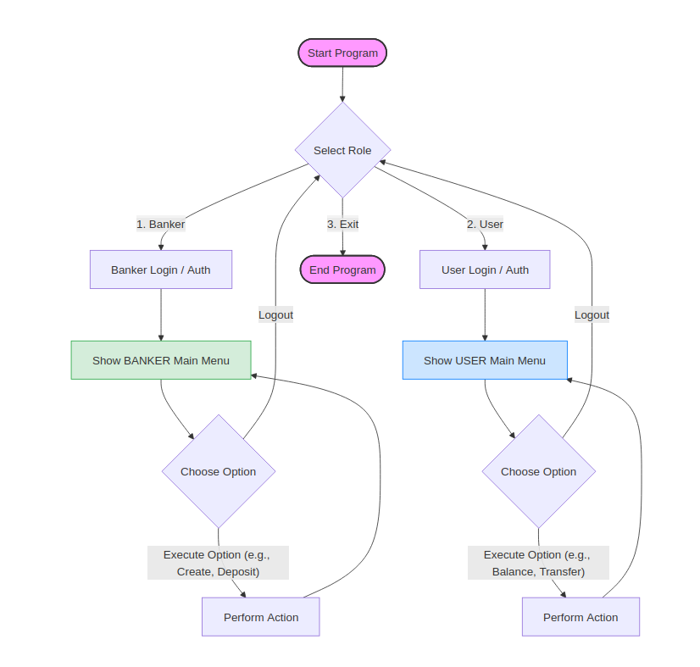

- Check balance:

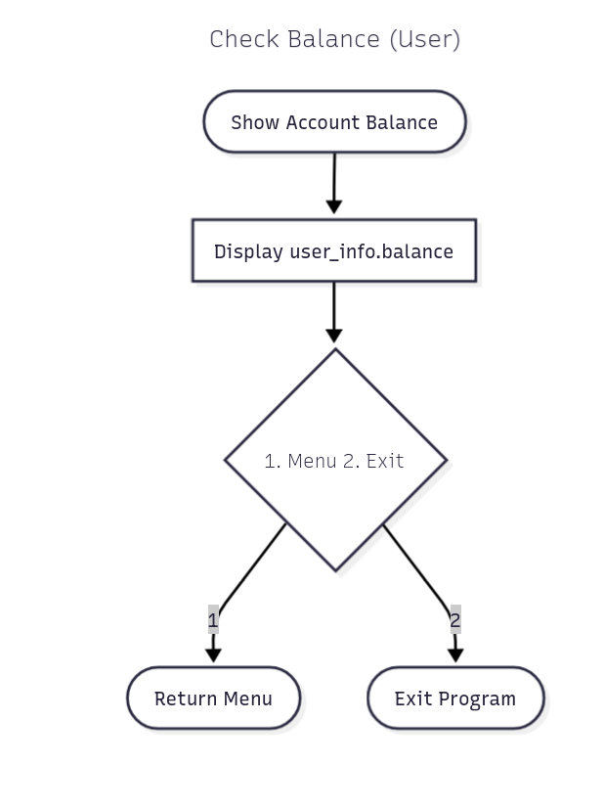

- User transaction:

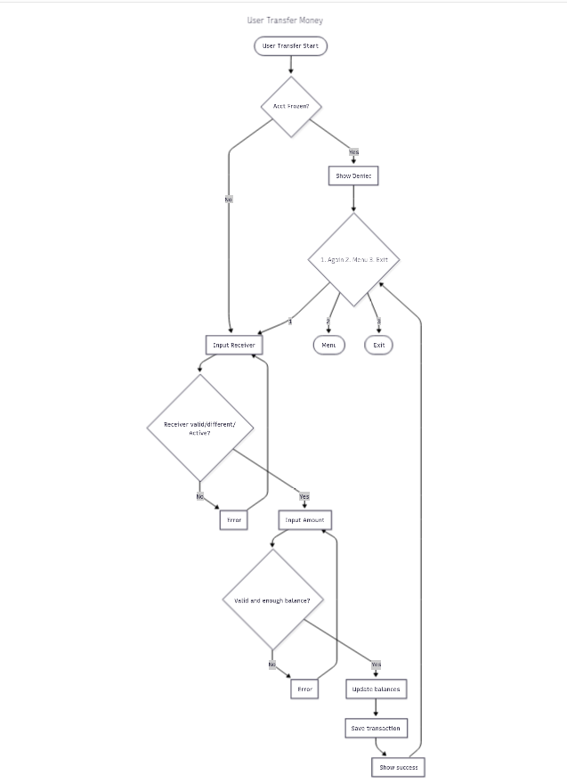

- User transaction history:

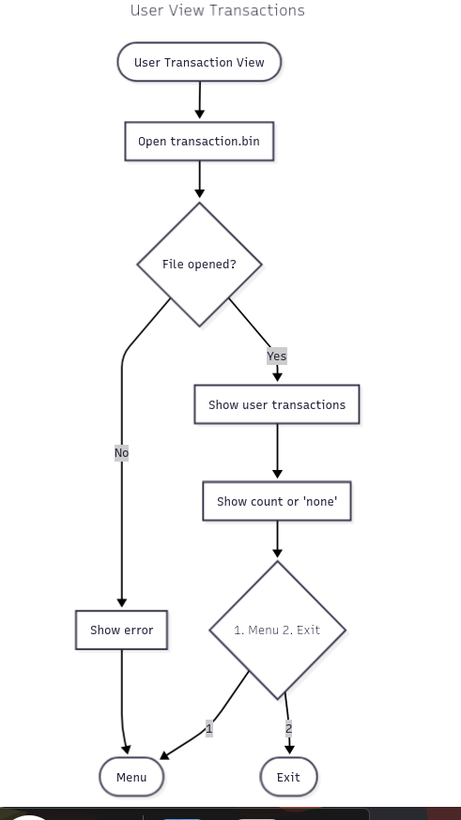

- User view account information:

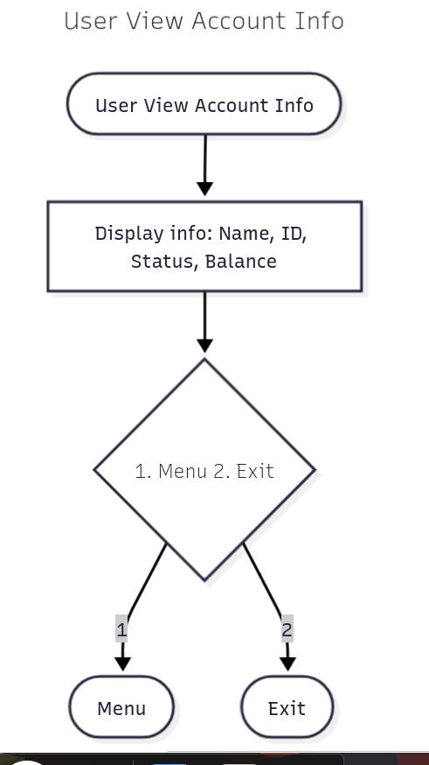

- View account:

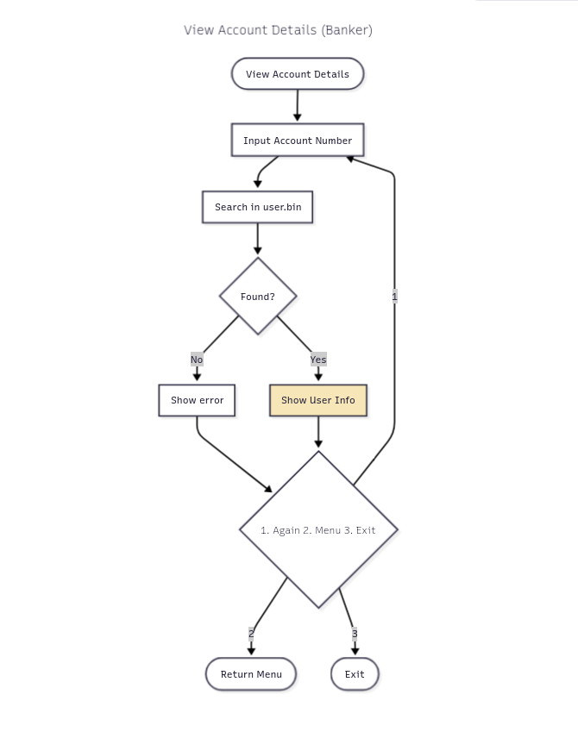

- Withdraw money:

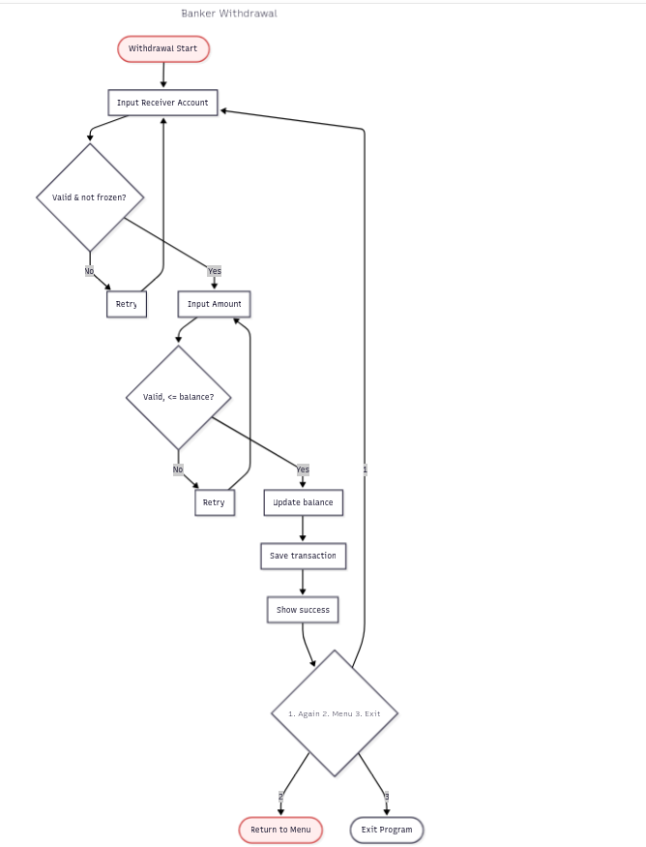

- Freeze account:

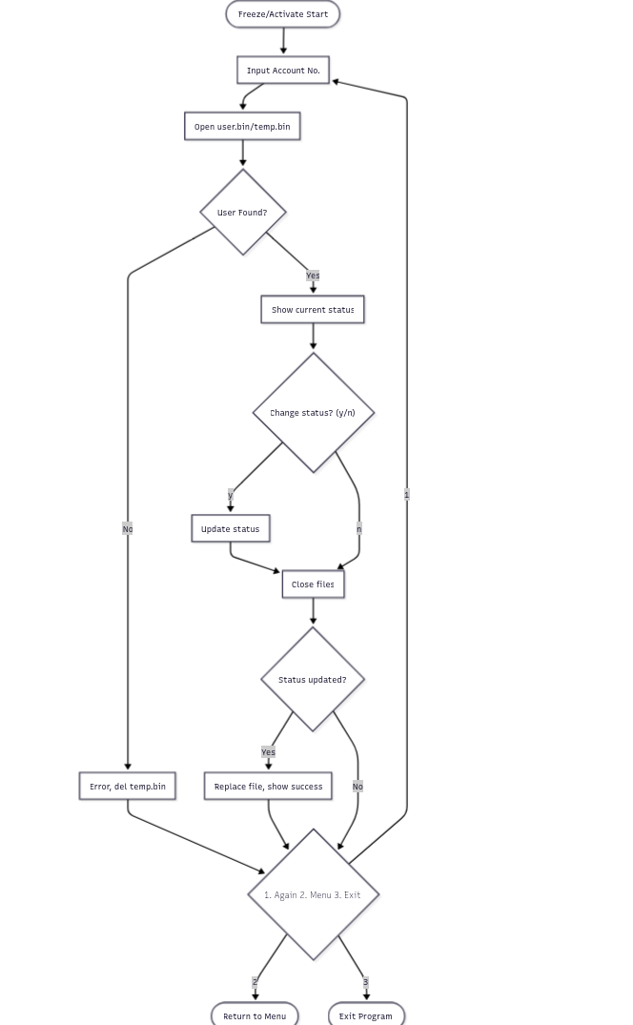
- Create account:

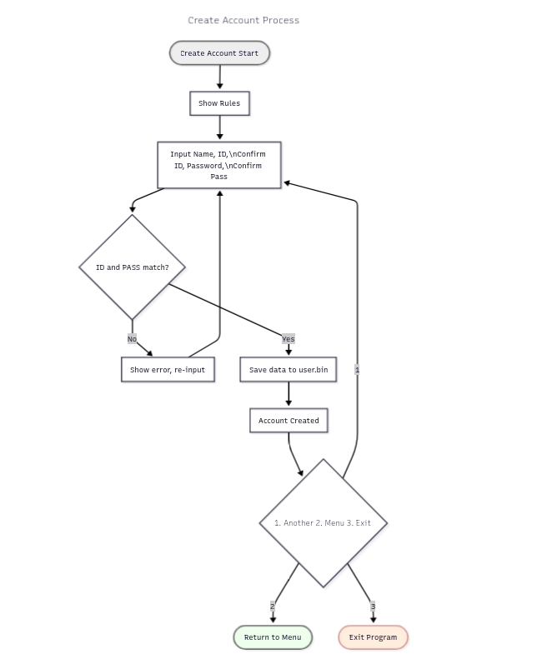

- Deposit money:

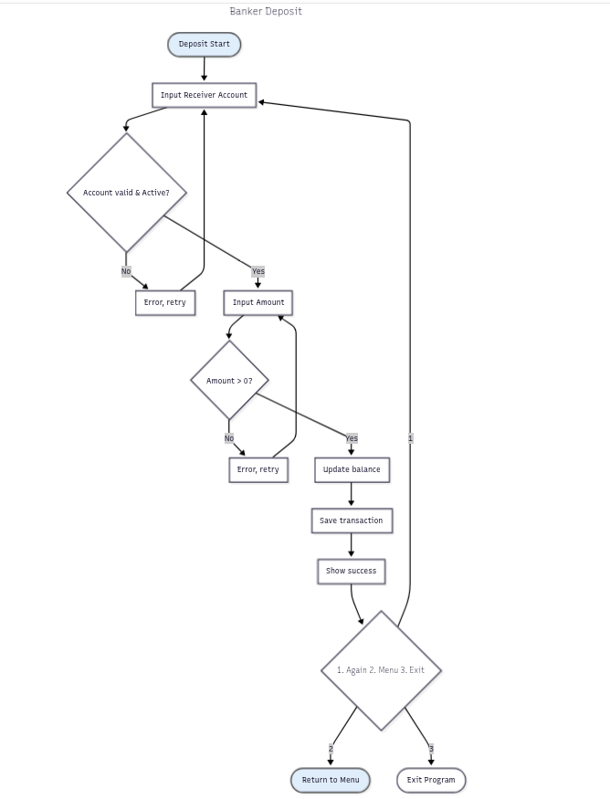
- Banker transaction history :

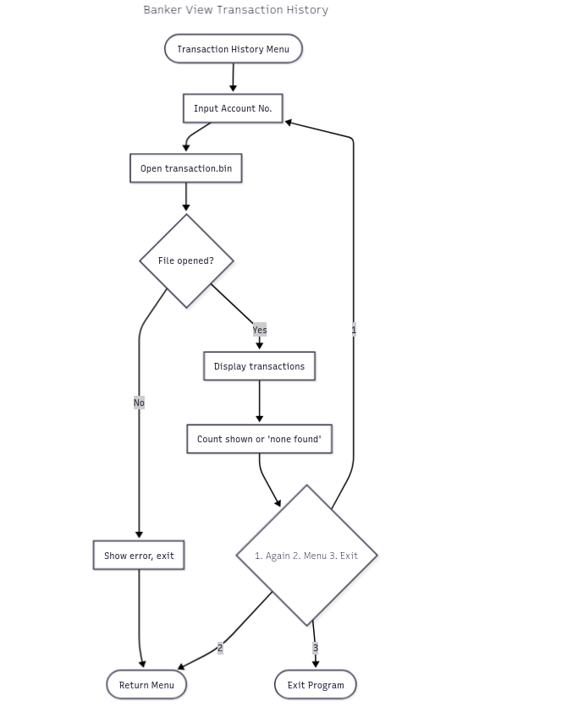
12)Update account:

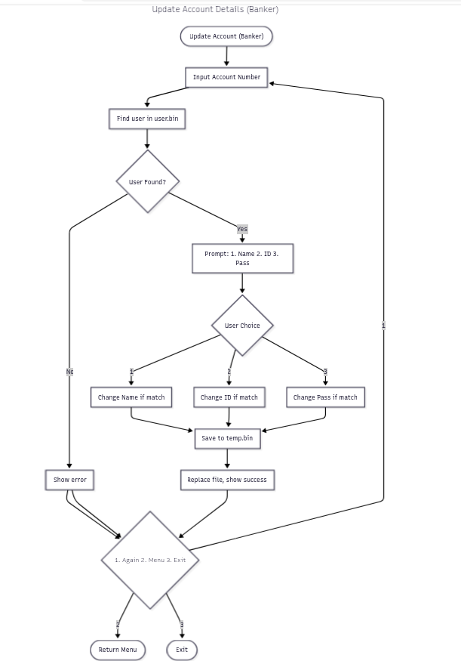
Implementation Details:

The Banking Management System (BMS) is implemented in the C programming language using a modular programming approach.
Some of the C concepts implemented are given below:

Control Statements:
The system makes extensive use of control statements to manage program flow:

- if else constructs are used for validation of user input, checking account existence, verifying sufficient balance before withdrawal, and handling error conditions

- switch case statements implement the menu-driven interface, allowing users to select banking operations such as viewing accounts, depositing money

- Looping constructs (while and do-while) are used to

- Continuously display menus until the user exits.
- Validate menu choices using conditions such as
do { scanf(...); } while(option != valid);.

Function:
TheProject is divided into multiple functions, each performing a specific task, such as:
- Viewing transactions
- Processing deposits and withdrawals
- Displaying customer records

This modular design:
- Improves readability
- Simplifies debugging
- Allows independent testing of each function

Structures
User and transaction data are organized using structures (struct), enabling related data to be grouped together logically.
Examples include:
- Customer account information
- Transaction records containing amount and type

Structures are passed to functions and written directly to files for persistent storage.

File Handling
The system uses file handling to store banking data permanently:

- Files are accessed using fopen() in appropriate modes.
- Records are written and read using fwrite() and fread().
- File pointers are used to sequentially process records.
- This ensures that customer and transaction data remain available even after program termination.

Conclusion:
Most of the fundamental concepts of C langue are used in this project.
Concept used:
- Control statements
- Loops
- Multiple functions
- Header files
- Structures
- File Handling
- Validation
- Arrays
- Strings
- Pointers

Results:

Main menu:

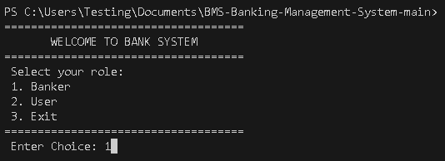

Banker:

Banker login:
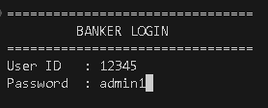sd

Banker menu :
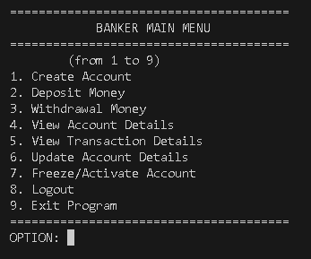

Create account:
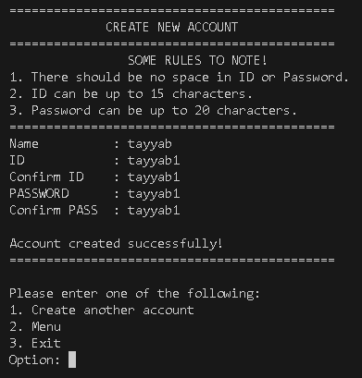

Deposit money
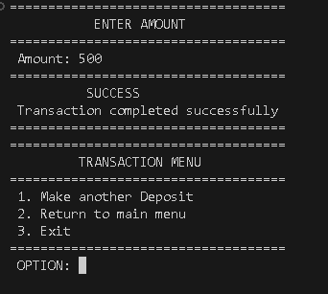

Account details:
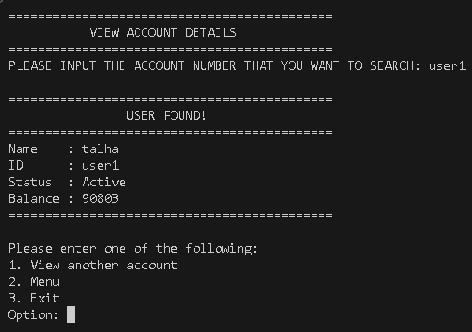

Account status
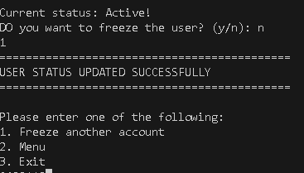

Update user account details:
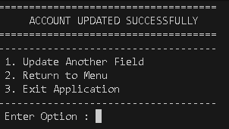

Transaction details :
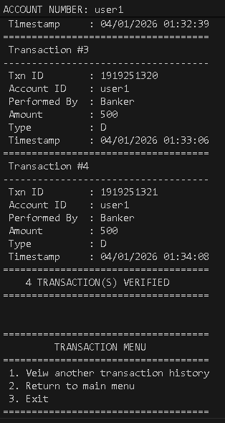

User:

Userlogin
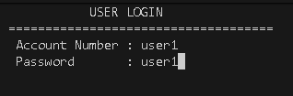

User menu:
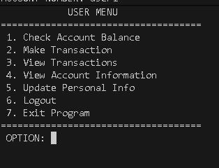

Check balance:
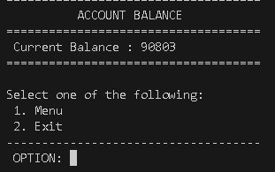

View transictions:
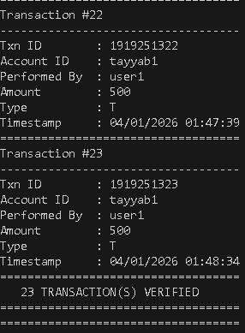

Update personal info:
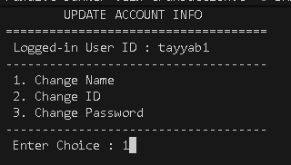

Limitations:

While the system successfully meets the semester requirements, there are limitations typical of a console-based semester project:

- Single User Concurrency:
- Security:
- Interface:

Conclusion:

The Banking Management System successfully demonstrates the capabilities of the C language. By completing this project, we learned how to manipulate memory using structures and pointers and how to persist data using file handling. The modular approach adopted in the code structure (main.c, banker-menu.c, user-menu.c) ensured that the code was readable, debuggable, and organized key skills for any IT related individual.

Future Work:

To enhance this project in future semesters, the following features could be added:

- GUI Implementation:
- Encryption:
- Network:
References:

- Let Us C By Yashwant Kanetkar
- Class notes
- Project github link

